Instructional Support Services Program

Online Academic Support Policies & Instructions FOR THE LEHMAN TUTORING CENTER

Weekly Appointments

  - Students

Scheduled Weekly Appointments
If you currently have scheduled weekly appointments in a specific discipline (Accounting, Business, Economics, Music, Psychology, Speech Pathology, Sociology, Social Work, foreign languages, and more), writing, and academic coaching, you will meet with a tutor/academic coach in an online session via Blackboard Collaborate Ultra. The online sessions will occur for 50 minutes on the same day and time as your scheduled in-person session.

Blackboard Collaborate Ultra offers a virtual room for tutors/coaches and students to remotely interact by chat, video, audio, whiteboard and file sharing. This means you will be able to see and hear each other, share files (must be in PDF, PowerPoint or Image formats), and annotate on a whiteboard. Instructions on how to use these features on Blackboard Collaborate Ultra can be found by clicking here.

PREPARING FOR YOUR SESSION
To prepare, we ask that you do the following:
- Find a quiet place with no distractions
- Make sure you’re on a desktop (we recommend one with a webcam, but it is not needed) or laptop computer
- Use Google Chrome as your web browser on Windows devices, and Safari or Firefox on Mac devices
- Wear headphones to reduce outside noise and prevent echoes
- Test your audio and video before each session

TO ACCESS YOUR SESSION
Log in every week to your TutorTrac account to check for a link to your session.
You can join the session up to 15 minutes before it starts, but no sooner. Your tutor/coach will join the session shortly before the start of the hour.

TUTORTRAC 4.0– TUTOR LOGIN INSTRUCTIONS
1. Open Mozilla Firefox.
2. To access TutorTrac to get to your Blackboard Collaborate session, go to: https://issp.lehman.edu/tracweb40/default.html.
You may receive a warning message in a pop-up box indicating the site is an “untrusted connection.” Under the “What should I do?” question that appears in the box, select “I understand the risks.” Lines of text will appear. Click on the “Add exception” button. Another pop-up box will appear. At the bottom left side of that pop-up box, click on “Permanently store this exception.” Then, go to the bottom right and click on the “Confirm security exception” button.
3. Enter your username (this is your Lehman email user name: firstname.lastname) and password (whatever your password is for your Lehman email). Click “Login.”
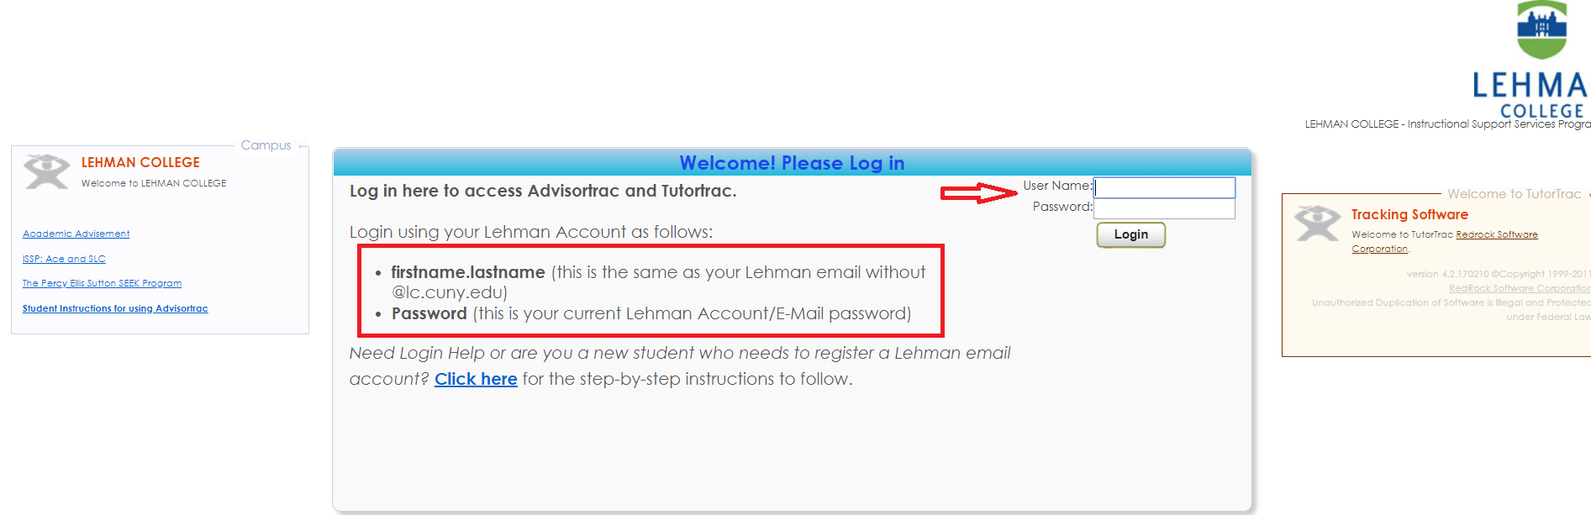
4. Look for the “Upcoming Appointments” box. You will see your upcoming appointments. Fifteen (15) minutes before your appointment is to begin, click on the blue button that indicates “Enter Blackboard Appointment.” This will take you to Blackboard Collaborate Ultra. Please log in with your first name, last name and last two (2) digits of your Cunyfirst ID.
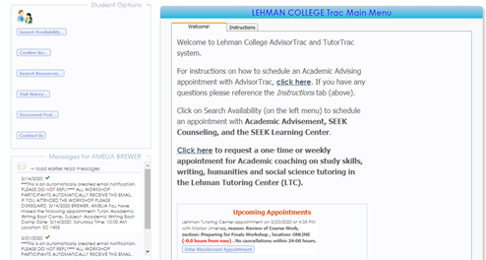
Click on this link to go to Blackboard for your online tutoring appointment
bTutorTrac Main Menu (includes important announcements).
5. When you log on, please make sure that the audio and video on your computer works.
For more information on how to use Blackboard Collaborate, please watch this video: https://www.youtube.com/watch?v=SQH-SkjMGOU&feature=youtu.be&list=PLontYaReEU1thrYkZR4tynKpyvuTB_dkD

When you click on the link to join the session, you will be prompted to:
- Enter a username: use the following format [first name] [last name] [last two digits of your EMPLID]. For example: “Jane Smith 67”
- Enable audio and video: click on the microphone and camera icons as shown below if you wish for your tutor/coach to hear and see you
- Share files: upload any files that you or your tutor/coach will use/refer to during the session. Supported file formats include .pdf, .ppt, .pptx, .png, .jpeg
Click to open “Collaborate panel” tab as shown below.
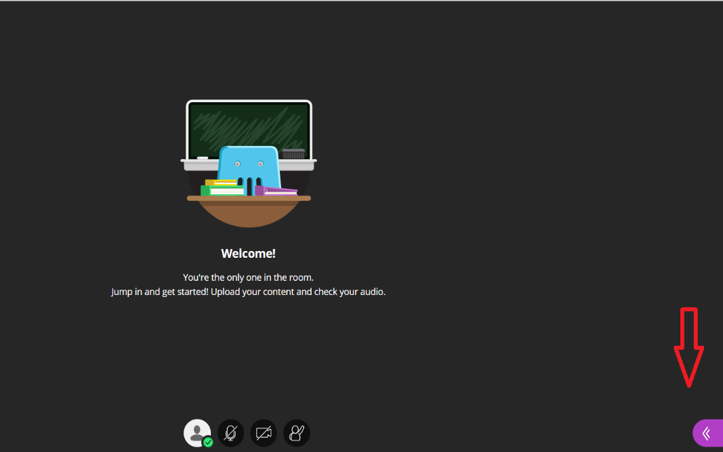

Click on “Share Files” and follow the instructions on the screen to upload files.
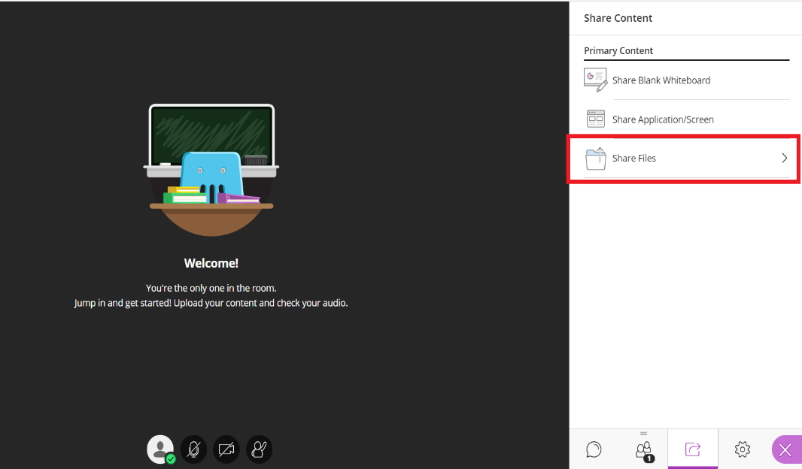

- Record: ask your tutor/coach if they would be comfortable with recording the session for future use or reference
Click to open “Session menu” tab as shown below.
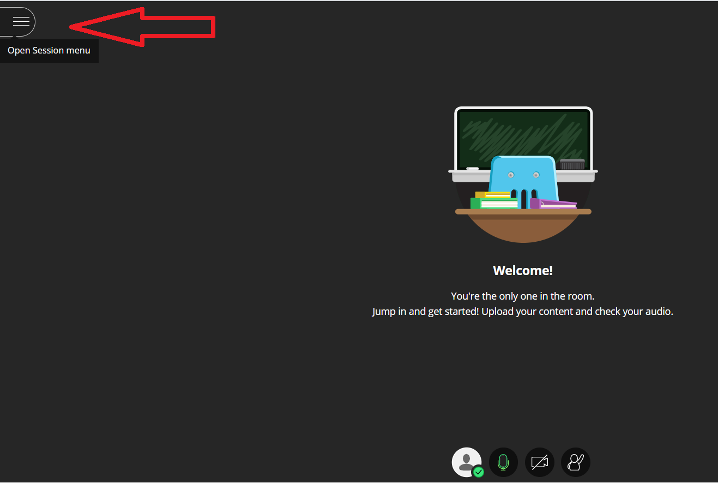

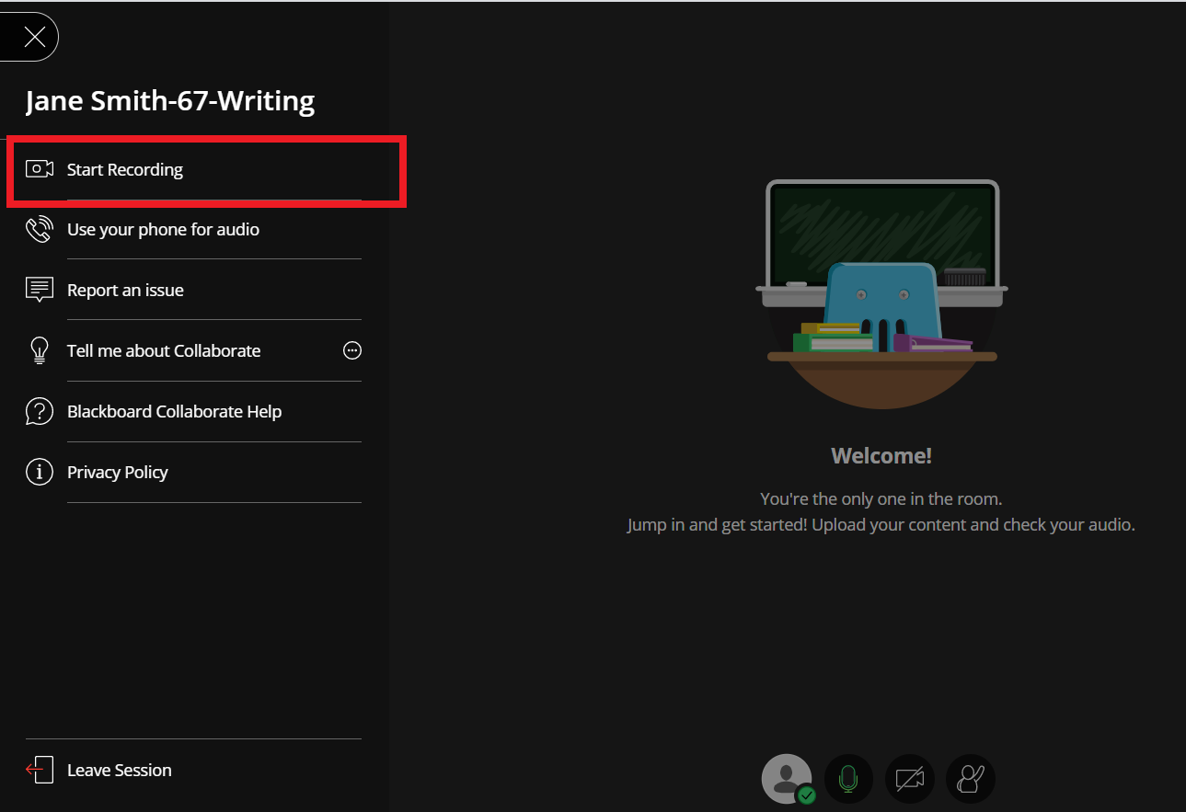
Click on “Start Recording” as shown below.

- Unable to access session:
  - due to technical difficulties: call the Lehman help desk at 718-960-1111 or email at help.desk@lehman.cuny.edu for any technical support in accessing or joining your session
  - due to other/non-technical difficulties: call the Lehman Tutoring Center at 718-960-8175 or email at issp.program@lehman.cuny.edu to let us know

- Canceling an appointment: If you would like to cancel an appointment, please email us at issp.program@lehman.cuny.edu with the subject “Appointment Cancellation”. Provide:
  - Your first and last names
  - Date and time of appointment being cancelled
  - Reason for cancelation

