SPAIN
evadeoVIAJES

Spain: Mudéjar Architecture
&Gastronomic Tour

◊ ITINERARY

Day 1 USA – SPAIN / MADRID
- Upon arrival at Adolfo Suárez Bajaras International Airport, you will be transferred to the hotel.
- Check-in to your hotel and time to have lunch in the hotel's restaurant. During the afternoon you will get to know Madrid by bus with a panoramic visit of the city. There will also be time for photo stops in the most emblematic places of Madrid: Paseo del Prado, Gran Vía, Plaza de España, Calle Mayor or Puerta del Sol.
- After the panoramic visit, spend the rest of the day exploring the city.
- Overnight stay at the hotel.
- Meals included: lunch

Day 2 MADRID
- After breakfast at the hotel, proceed for your guided tour through the Royal Palace and "The Madrid of the Austrians", this name has been used to design the old centre of the city built during the reign of the Habsburg Dynasty.
- In the afternoon, let's feel like a local and enjoy the incredible "Tapas and Wine Route" which includes a visit of three bars, with wine tasting and 2 different tapas in each place.
- Then, spend the rest of the day discovering Madrid or choose an optional tour of The Prado Museum and El Retiro Park.
- Overnight stay at the hotel.
- Meals included: breakfast and lunch (tapas & wine).
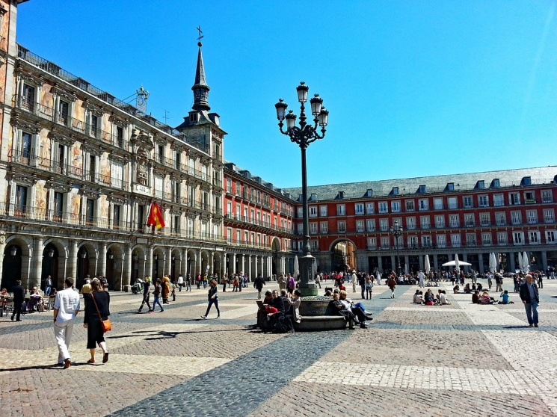

Day 3 MADRID – TOLEDO – CORDOBA
- After breakfast at the hotel, check out and head towards Toledo.
- Toledo is the best place in Spain to find out how three different religions (Christianity, Judaism, and Islam) managed to live in harmony and peace. Before lunch in a local restaurant, you will take a guided tour of Toledo to discover more about its culture and history.
- After lunch, head towards Cordoba. Check-in upon arrival and dinner at the hotel.
- Overnight stay at the hotel.
- Meals included: breakfast, lunch and dinner.
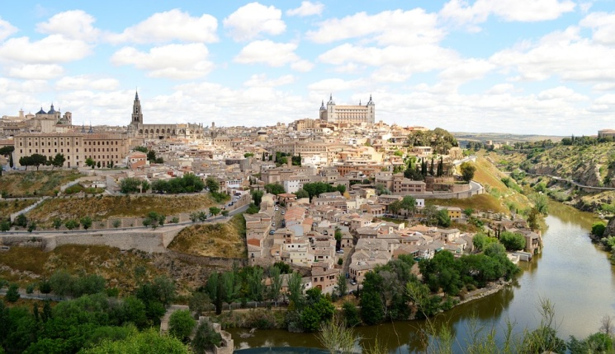

Day 4 CORDOBA
- Breakfast at the hotel and then guided tour of Cordoba. You will visit the most wonderful mosque of Spain (now turned into a Cathedral), the Alcazar and Paseo de la Judería.
- After the tour you will have free time to stroll about.
- Overnight stay at the hotel.
- Meals included: breakfast.

Day 5 CORDOBA - SEVILLA
- Breakfast at the hotel, check-out and departure from the hotel towards the Natural Park of La Sierra Norte of Sevilla.
- This beautiful park is the perfect place to enjoy a leisurely time while visiting the vineyards and the wine cellar Colonias de Galeon. After the visit you will have the opportunity to taste 6 different types of wine.
- At the end of the visit you will have lunch in a local restaurant and then depart for the hotel in Sevilla.
- Overnight stay at the hotel.
- Meals included: breakfast and lunch.

Day 6 SEVILLA
- Breakfast at the hotel.
- Sevilla is considered the most important city in Southern Spain. It is the capital of the region of Andalucia and it has a lot of emblematic monuments such as: the Cathedral and its tower named La Giralda or the Alcazar where the Spanish kings used to live, and that recently served as a setting for the TV series "Game of Thrones". You will have time to visit these monuments and discover more about their history during the guided tour.
- After the tour: free time to visit the city on your own and have lunch in one of the many restaurants of the old town.
- In the evening, you will attend an astonishing Flamenco Show of 1h30min (one drink included) where you can experience the passion for this traditional dance and its music.
- Overnight stay at the hotel.
- Meals included: breakfast.
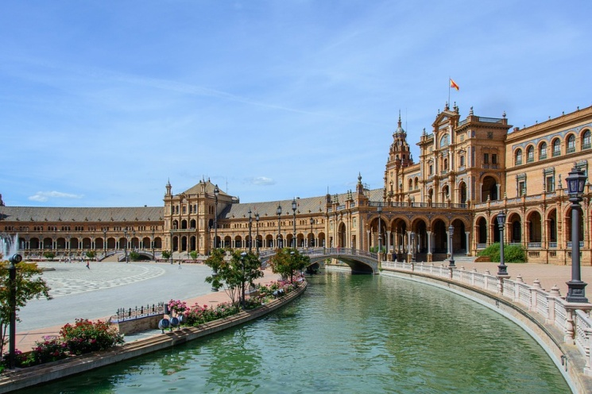

Day 7 SEVILLA - GRANADA
- Breakfast at the hotel, check-out and departure towards Granada.
- On arrival, check-in and lunch at the hotel. During the afternoon, you will have a guided tour of the old town of Granada and the Albayzin, an old Arabian quarter located in a strategic place of the city from which you have great views of La Alhambra.
- Spend the rest of the day visiting the city.
- Overnight stay at the hotel.
- Meals included: breakfast and lunch.

Day 8 GRANADA
- Breakfast at the hotel.
- Throughout the morning, you will discover La Alhambra with a guided tour. You will have time to visit the numerous rooms and gardens of this palace while your guide explains why it is considered one of the most important monuments of Spain.
- After this magical tour: free time to buy some souvenirs, take photos and enjoy some tapas in the city centre.
- In the evening, you will have a special farewell dinner in a well-known restaurant in Granada.
- Overnight stay at the hotel.
- Meals included: breakfast and dinner

Day 9 GRANADA - MADRID
- Breakfast, check-out and departure at 7:00am towards Madrid.
- Arrival in Adolfo Suarez Barajas International Airport and end of the trip.

◊ FLIGHT SUGGESTIONS

JUNE, 9 > New York (22.05) – Madrid (11.30 + 1)
JUNE, 18 > Madrid (15.15) – New York (17.40)

Direct flights operated by Air Europa.
Please go to www.expedia.com to book the flights.

◊ HOTELS

Madrid: HOTEL H10 VILLA DE LA REINA 4*
Cordoba: HOTEL NH CALIFA 3*
Sevilla: HOTEL HESPERIA NH SEVILLA 4*
Granada: HOTEL MONJAS DEL CARMEN 3*

◊ TOUR INCLUDES

- Tour coordinator during all program.
- All transfers in coach buses.
- Accommodation in twin or single rooms (2 nights in Madrid, 2 nights in Cordoba, 2 nights in Sevilla and 2 nights in Granada).
- City tours in English with official guides in: Madrid, Toledo, Córdoba, Sevilla and Granada.
- Tickets for monuments included in each city tour.
- 8 breakfasts, 5 lunches (includes the Tapas and Wine Route), 2 dinners.
- Visit to a vineyard and its wine cellar with tasting.
- Flamenco Show + one drink.
- Travel insurance.

◊ PRICES PER PERSON

DOUBLE | SINGLE
$ 1,465 | $ 1,845
Thank you for choosing Evadeo Viajes!

