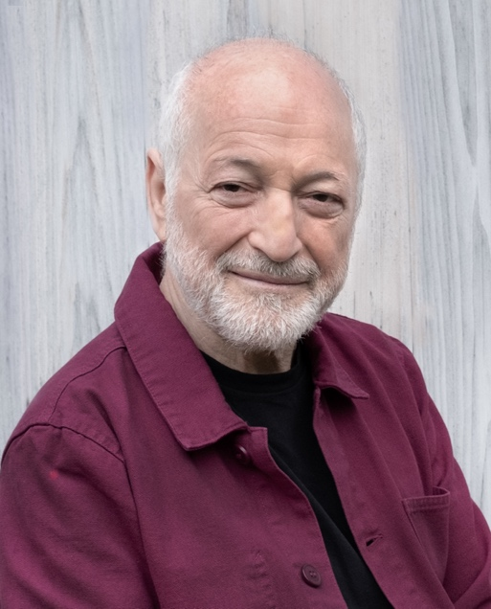
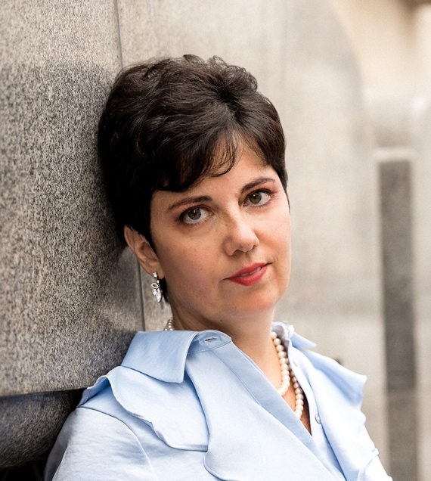
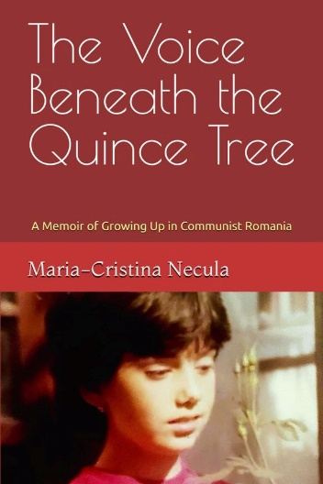
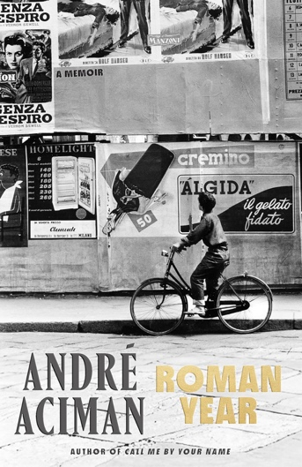
Thursday, March 13, 2025
6:00 - 7:30 PM
Library Periodicals Room - Concourse level
RSVP by March 12: https://libcal.lehman.edu/event/14165277
*Registration is required*
https://andreaciman.com/
https://mariacristinanecula.com/

Refreshments will be served

Join us for a special conversation with two Lehman College alumni writers, both graduates of the English Department

Internationally celebrated novelist and memoirist André Aciman, BA '73, and prize-winning author Maria-Cristina Necula, MA '14, appear together to discuss themes of exile, growing pains, identity, oppression, finding refuge in literature and opera, immigration to New York, in their recently published memoirs: Roman Year (Aciman) and The Voice Beneath the Quince Tree (Necula).

Discussion will be facilitated by Paula Loscocco, professor in the English Department

Leonard Lief Library
presents
In Search of the Lost Home:
A Reading and Discussion


Maria-Cristina Necula

André Aciman

