

Leonard Lief Library
English
present
A Reading and Discussion

Rhetoric and Resistance
The Literary Arts of Dissent in Nineteenth-Century Britain
by Maeve Adams
Rhetoric and Resistance explores the transformative role of 19th century literature in shaping modern concepts and practices of democratic dissent.
By examining works of Romantic and Victorian novelists, poets, and journalists - Maeve Adams identifies origins of modern theories and practices of resistance in 19th century literary forms.
Offering a literary history of dissent - the book recovers the intertwined development of democracy and aesthetics, revealing how narrative form became a potent tool for challenging authority.
Tracing the lineage of dissent from the radical fiction and journalism of the 1800s to contemporary movements like #MeToo - Adams offers a genealogy that highlights how literary texts experimented with political power, granting new and consequential voices to working class individuals, women, colonized peoples, and other marginalized groups.
Maeve Adams is Assistant Professor of English at Lehman College.
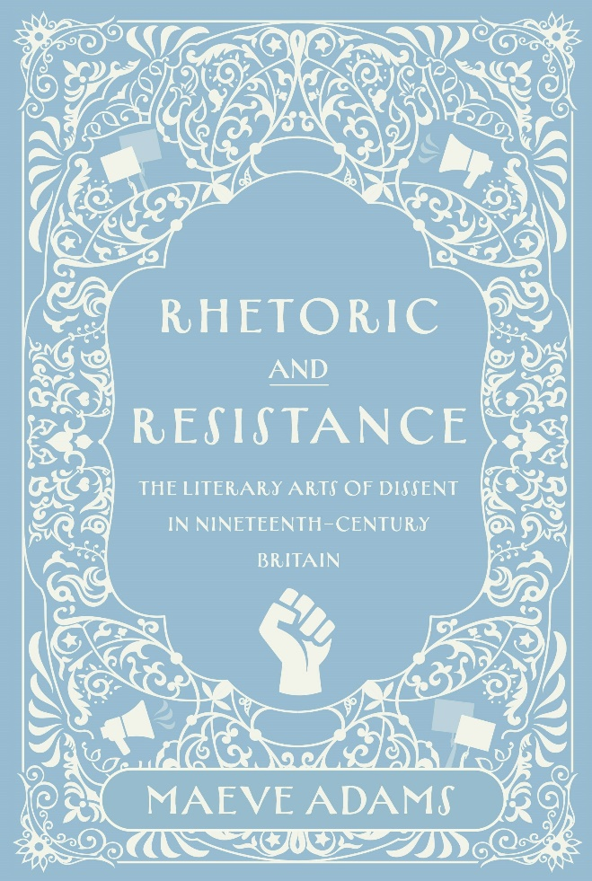

Tuesday, October 21, 2025
12:00 - 1:00 PM
RSVP by October 20th: https://libcal.lehman.edu/event/15520276
Location: Library - Treehouse Conference Room 317
*Registration is required*
Information: Bernice.Suphal@lehman.cuny.edu

